Chapter 12 Demo Requirements
Oct 28, 2026 · @Jim Kaufmann

Overview
Seven small C# Windows Forms (.NET 10) demos, one for each Chapter 12 lab. Each demo practices the same skills as its lab but uses a different scenario, so the lab code is still yours to write. Name the projects Demo1 through Demo7.
Demo | Project | Same skills as | Scenario | Key concepts
1 | PetLookup | Lab1 SuperHeroDatabase | Look up shelter pets | ComboBox filled in code, a "(none)" option, a custom class
2 | MenuFinder | Lab2 JobDatabase | Search a restaurant menu | Multi-select ListBox, a second window, a class that holds an array of objects
3 | HighlightPad | Lab3 Clock | Color four TextBoxes | Mouse, focus, and keyboard events, KeyPreview, shared handlers
4 | BookSearch | Lab4 MultiSearch | Search a small library | Two search fields, Enter key runs the search (PerformClick)
5 | TeamRoster | Lab5 StudentList | One team's roster | List<T>, add and remove, RichTextBox
6 | TeamDictionary | Lab6 StudentDictionary | Roster keyed by jersey number | Dictionary<TKey, TValue>, search by key
7 | LeagueRosters | Lab7 StudentCourses | Two teams, separate rosters | A collection of objects that each hold a List

Demo requirements

Demo1 PetLookup
Create a GUI application to look up pets available for adoption at an animal shelter.
- Program must contain information about 3 pets.
- Create a Pet class that holds all of the information about a single pet: name, species, age, and description.
- The ComboBox must be populated programmatically when the form loads.
- The ComboBox must contain a "(none)" option. Selecting it clears the display.
- When the user selects a pet, display all of its information in labels.

Demo2 MenuFinder
Create a GUI application to search a restaurant menu by category.
- Program must contain 3 categories: Breakfast, Lunch, and Dessert.
- Program must contain 6 menu items, 2 per category.
- Create a MenuItem class that holds the name, price, and calories of one item.
- Create a Category class that holds the category name and an array of MenuItem objects.
- The ListBox must be populated programmatically and must allow multiple categories to be selected.
- Clicking the Search button shows the matching items in a new window.
- The results in the new window must be populated programmatically.
- If no category is selected, show a message instead of opening the window.

Demo3 HighlightPad
Create a GUI application that demonstrates mouse, focus, and keyboard events on 4 TextBoxes.
- When the user clicks a TextBox, change its background color to LightPink.
- When a TextBox receives focus, change its background color to LightGreen.
- When a TextBox loses focus, change its background color to White.
- When the user presses F1, F2, F3, or F4, move the focus to TextBox 1, 2, 3, or 4.
- A label at the bottom shows the last event that fired, for example "Enter: txtBox2".
- All 4 TextBoxes share one handler per event (use the sender parameter).

Demo4 BookSearch
Create a GUI application that searches a small library by book title or by author.
- Program must contain 5 books. Create a Book class with title, author, year, and genre.
- The user can search for a book by title.
- The user can search for a book by author.
- Searches ignore uppercase and lowercase.
- When a book is found, display its title, author, year, and genre. If several match, show the first one.
- When no book is found, display an error message.
- Pressing Enter in a TextBox runs that TextBox's search. (Hint: PerformClick)

Demo5 TeamRoster
Create a GUI application that manages one sports team's roster with a List.
- Create a Player class with jersey number, first name, last name, and position. Override ToString() to show "#7 Alex Rivera (Guard)".
- Create a Team class that has a name and a List of Player objects.
- When the form loads, show 4 players in a RichTextBox.
- Provide a way to add a player to the team. Update the RichTextBox to reflect this.
- Provide a way to remove a player from the team. Update the RichTextBox to reflect this.

Demo6 TeamDictionary
Create a GUI application that manages one team's roster with a Dictionary.
- Create a Player class (same as Demo5).
- Create a Team class that has a name and a Dictionary of Player objects. Use the jersey number as the key.
- When the form loads, show 4 players in a RichTextBox.
- Provide a way to add a player. If the jersey number is already taken, show a message and do not add the player.
- Provide a way to remove a player by jersey number. Update the RichTextBox to reflect this.
- Provide a way to search for a player by jersey number.

Demo7 LeagueRosters
Create a GUI application that manages the rosters of 2 teams.
- Create a Player class and a Team class (same as Demo5).
- Create a List of 2 teams. Each team has its own List of Player objects.
- Let the user select a team from a ComboBox and see only that team's players.
- Provide a way to add a player to the selected team.
- Provide a way to remove a player from the selected team.

UML class diagrams
Each box is a class: its name on top, then its fields and properties, then its methods. + means public and - means private. A hollow diamond marks the class that holds the other one; 0..* means zero or more. A dashed arrow means one class opens or uses the other.
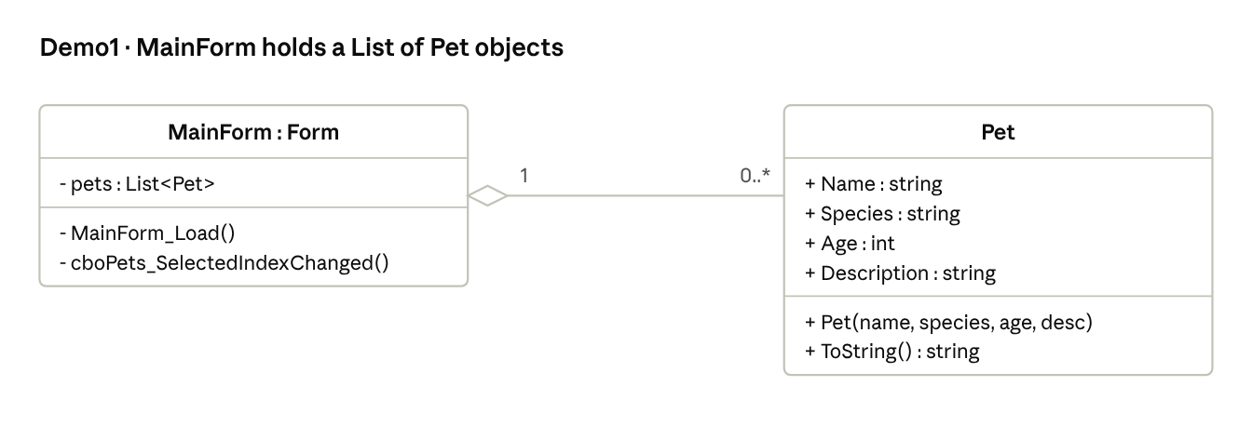
Demo1 PetLookup · class diagram
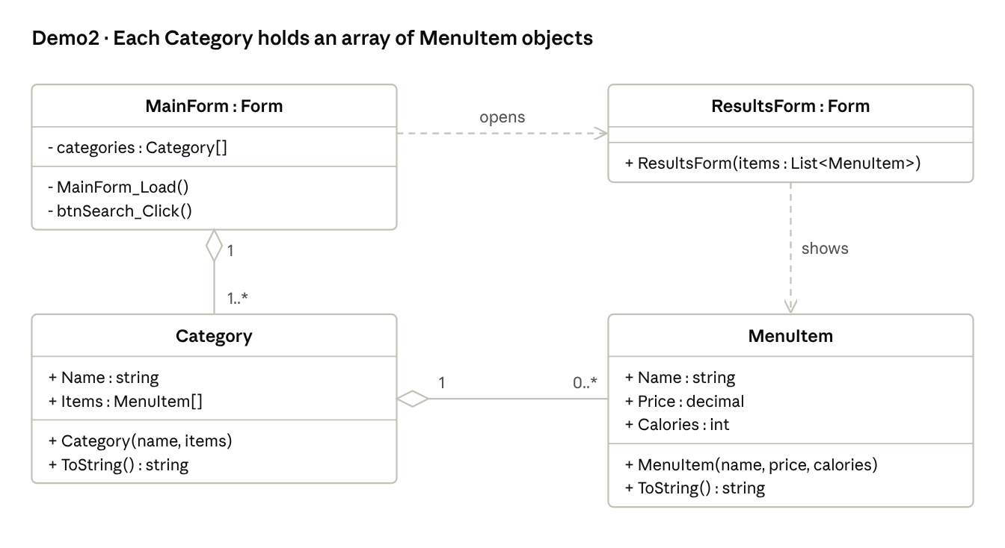
Demo2 MenuFinder · class diagram
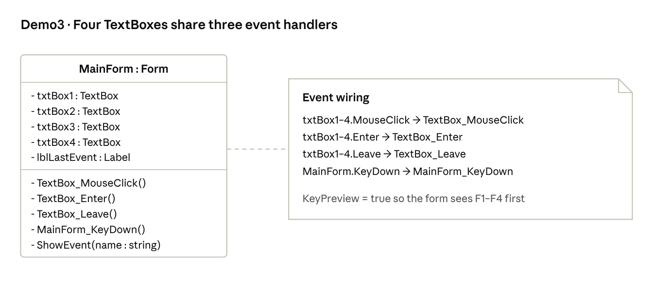
Demo3 HighlightPad · class diagram
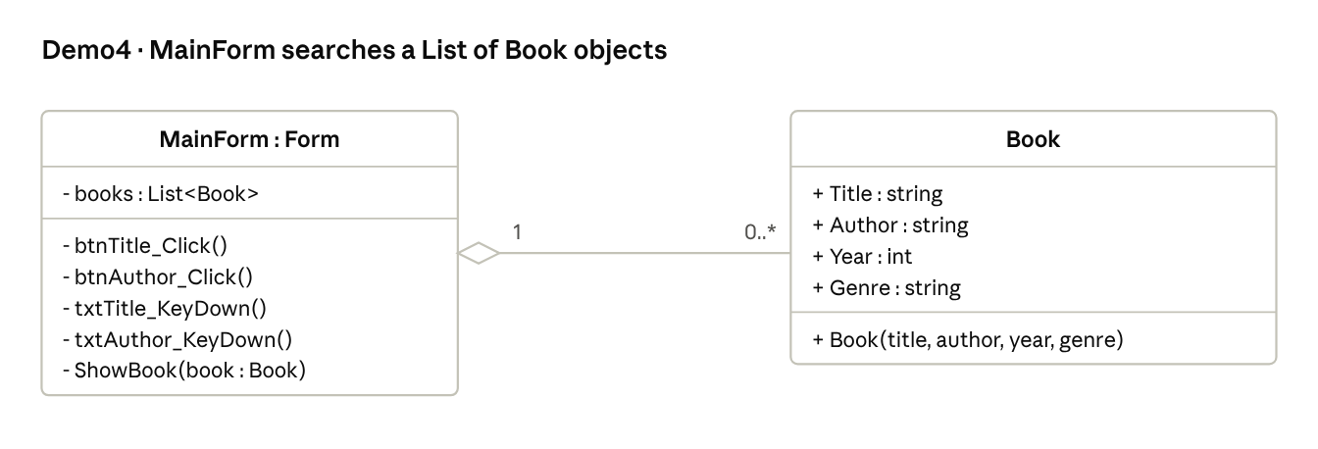
Demo4 BookSearch · class diagram
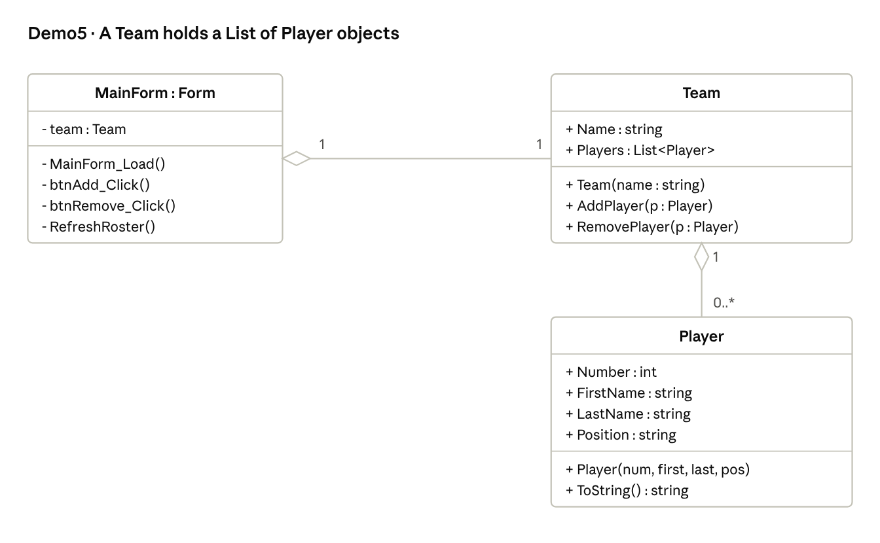
Demo5 TeamRoster · class diagram
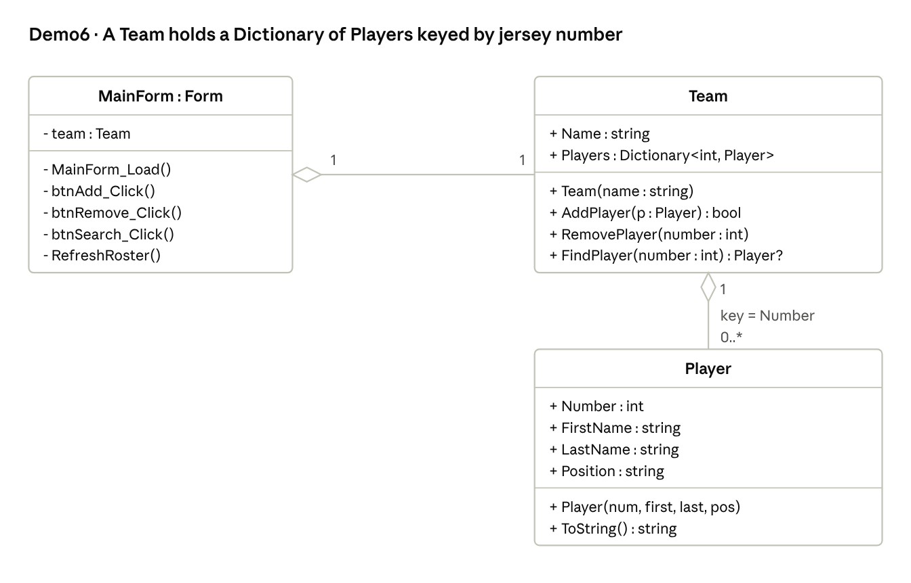
Demo6 TeamDictionary · class diagram
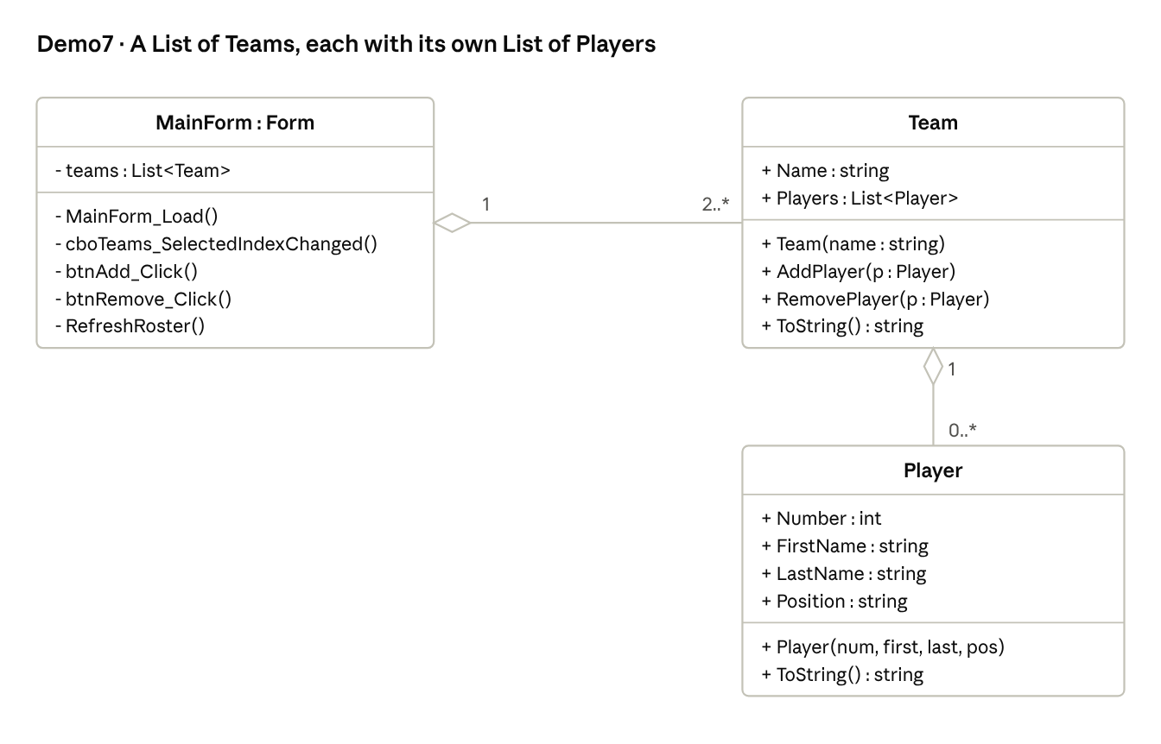
Demo7 LeagueRosters · class diagram

Sample data
Hard-code this data in each demo so the demos and the UML line up.
Demo1 pets
Name | Species | Age | Description
Biscuit | Dog | 3 | Friendly beagle who loves long walks
Whiskers | Cat | 5 | Calm tabby who naps in sunny windows
Pebbles | Rabbit | 1 | Curious lop-eared rabbit
Demo2 menu items
Category | Item | Price | Calories
Breakfast | Pancakes | $6.50 | 520
Breakfast | Omelet | $7.25 | 410
Lunch | Turkey Club | $8.99 | 640
Lunch | Garden Salad | $6.75 | 320
Dessert | Brownie | $3.50 | 380
Dessert | Apple Pie | $4.25 | 410
Demo4 books
Title | Author | Year | Genre
Pride and Prejudice | Jane Austen | 1813 | Romance
Frankenstein | Mary Shelley | 1818 | Horror
Treasure Island | Robert Louis Stevenson | 1883 | Adventure
The Time Machine | H. G. Wells | 1895 | Science fiction
Dracula | Bram Stoker | 1897 | Horror
Demo5–7 players (Demo5 and Demo6 use only the Rockets)
Team | Number | First name | Last name | Position
Rockets | 7 | Alex | Rivera | Guard
Rockets | 12 | Jordan | Lee | Forward
Rockets | 23 | Sam | Patel | Center
Rockets | 31 | Casey | Brooks | Guard
Comets | 4 | Taylor | Nguyen | Guard
Comets | 9 | Morgan | Diaz | Forward
Comets | 15 | Riley | Chen | Center

